****­

**Chair Recruitment**

**Candidate Information Pack**

**October 2017**

**Contents**

About Trivallis 3

Come and Work with us (Video) 5

The Current Board 6

The Executive Team 9

The Role 12

The Person 14

Terms of Appointment 19

How to Apply 20

Indicative Timetable 21

Further Information 21

**About Trivallis**

Trivallis (Formerly RCT Homes) was set up as Wales’ first housing community mutual in December 2007, following a stock transfer of over 10,000 homes from Rhondda Cynon Taf Council.

Following a brand consultation, we launched with the new name, “Trivallis” in July 2016. We then collapsed our group structure in September 2016.

Being a community mutual means we are run by our tenants, for our tenants. As well as being part of decision-making processes at all levels of the organisation – from recruiting our next Chief Executive to checking our repairs are right first time – tenants are also consulted to make sure we are doing the right things in the right places at the right time.

Our homes, which were primarily built in the 1950s and 60s, are located on more than sixty housing estates throughout the former mining communities of Rhondda Cynon Taf.

When tenants voted in favour of transferring the ownership and management of their homes to us, we embarked on a mammoth task of bringing our homes up to the Welsh Housing Quality Standard (WHQS) by the end of 2012.

Our ambitious programme involved making nearly 60,000 improvements to 97% of our properties and an investment of more than £140 million. It also included bringing more than 500 empty properties – some of which had been vacant for more than a decade – back into our housing stock. By the end of

2012 we had achieved our programme. In addition we achieved all 86 investment and service improvement Promises made to tenants at transfer. Our Planned Maintenance Programme continues to deliver improvements and maintenance to our homes.

In 2013 we embarked on our first house build programme, using traditional funding methods. We now have a development programme which is helping to develop sustainable communities and deliver on much needed affordable housing throughout the valleys.

Our multi-million pound Neighbourhood Spaces programme has been rolled out throughout many of our estates. Working closely with our tenants we plan and deliver improvements to community spaces that make a real difference to how people feel about where they live – and provide opportunities to bring the community together.

Trivallis is about more than just bricks and mortar (and kitchen sinks and bathroom suites). We also focus on the regeneration of our communities.   
We want to tackle poverty, regenerate communities and help people into work and training.

Since 2007 we have delivered over £12 million of social value for our customers and communities through our added value support services, charity, social enterprise, projects and volunteering.

We work with partners to deliver much-needed programmes and projects that support our communities to be stable, thriving and ambitious.

As well as offering grants and match funding for projects we deliver social value through our procurement process, ensuing local suppliers and local people benefit from contracts and job creation. Our staff are actively encouraged to take part in volunteering events and our annual Give and Gain days are a highlight in our calendar.

We were named the Business in the Community Wales’ Responsible Company of the Year for the second time in 2014 and have been shortlisted again in 2017.

**Our Vision is:**

*'To be trusted as an open and inspiring organisation that changes people’s lives and communities for the better.'*

**Our Values**define how we aim to achieve this vision, what we believe in and how we go about our work:

**Listen…**

…because we listen when people talk to us, and we respond to what they say. We’re open, friendly, and we talk in their language. We treat people as individuals, whoever they are and whatever their background.  Our experience and knowledge mean we know what we’re talking about, but we don’t alienate others with long words and big talk. We demonstrate our understanding through action.

**Engage…**

…because we make a difference to people’s lives. We offer them opportunities to improve their own prospects, and we enable them to take control of their own future. Our positive attitude is infectious and reassuring, and our practical help and dedicated support makes people feel empowered to take the initiative.

**Respect…**

…because we’re honest and transparent in the way we do things. We’re seen as a credible and reliable organisation that is open to collaboration and that delivers on our promises. We’re always fair in the way we conduct ourselves, and we have the utmost respect for others.

**Progress...**

…because we inspire others with our bold and innovative approach. We’re not afraid to do things differently, to try new things, to lead the way - but we do so with humility. We’re energetic, focused, and intent on making progress. We are not satisfied with mediocre and we are not content to stand still. Our energy is a powerful force for change.

**Come and work with us**

Hear directly from the people of Trivallis why you should choose to join Trivallis and what you can expect from working for this organisation.

(External link)

**[](https://www.youtube.com/watch?v=b5BjrxLMr34)**

**The Current Board**

**Claire Jones – Retiring Chair**

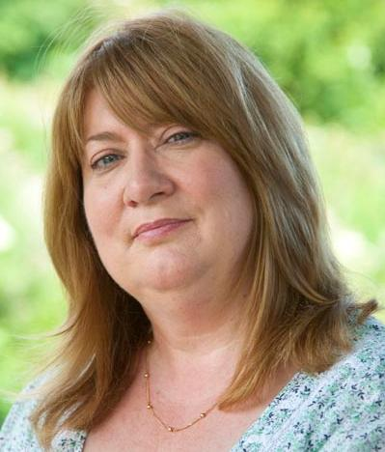An Independent Board Member, Claire has worked in the Housing sector in Wales for more than twenty years; during which time she has been involved in a number of renewal and regeneration projects.

Claire currently coordinates Housing Strategy Commissioning and Partnering for Neath Port Talbot Borough Council.

Claire has been Chair of the Board since 2011.

**Ken Bowles**

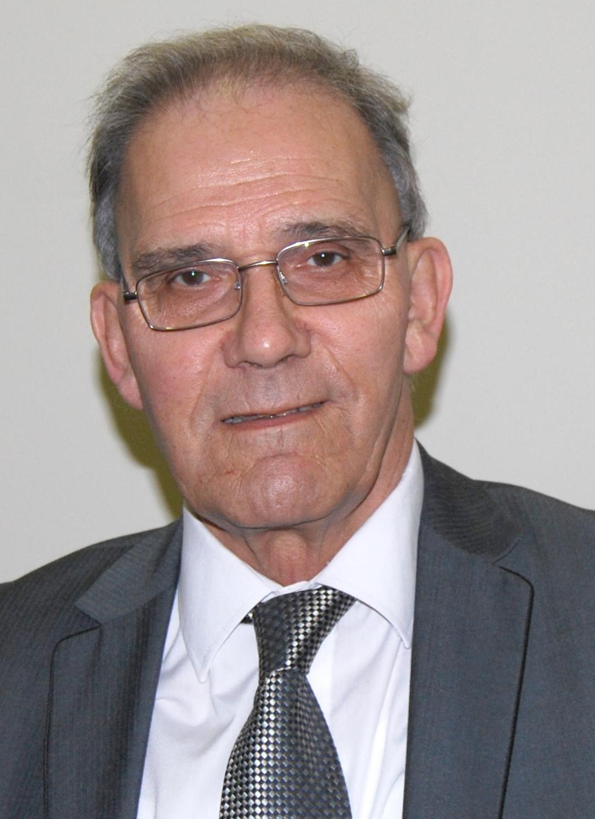

Ken is a qualified accountant and spent eighteen years working for a local authority where he became a project manager responsible for furnishing and fitting out major buildings.

He has used his skills and experience by playing a central role in the selection of contractors for Trivallis’ multi-million pound Planned Maintenance Programme framework.

Ken is resident of The Haven sheltered housing complex in Hirwaun.

**Paul Mee**



Paul is the Service Director for Public Health & Protection at Rhondda Cynon Taf County Borough Council.

He is responsible for a number of council services including Housing Strategy & Standards, Environmental Health, Trading Standards, Licensing, Community Safety, Bereavement Services and Registration Services.

Paul has worked in local government since qualifying as an Environmental Health Officer in 1991 and has held his current position as Service Director since 2007.

**Kel Palmer**

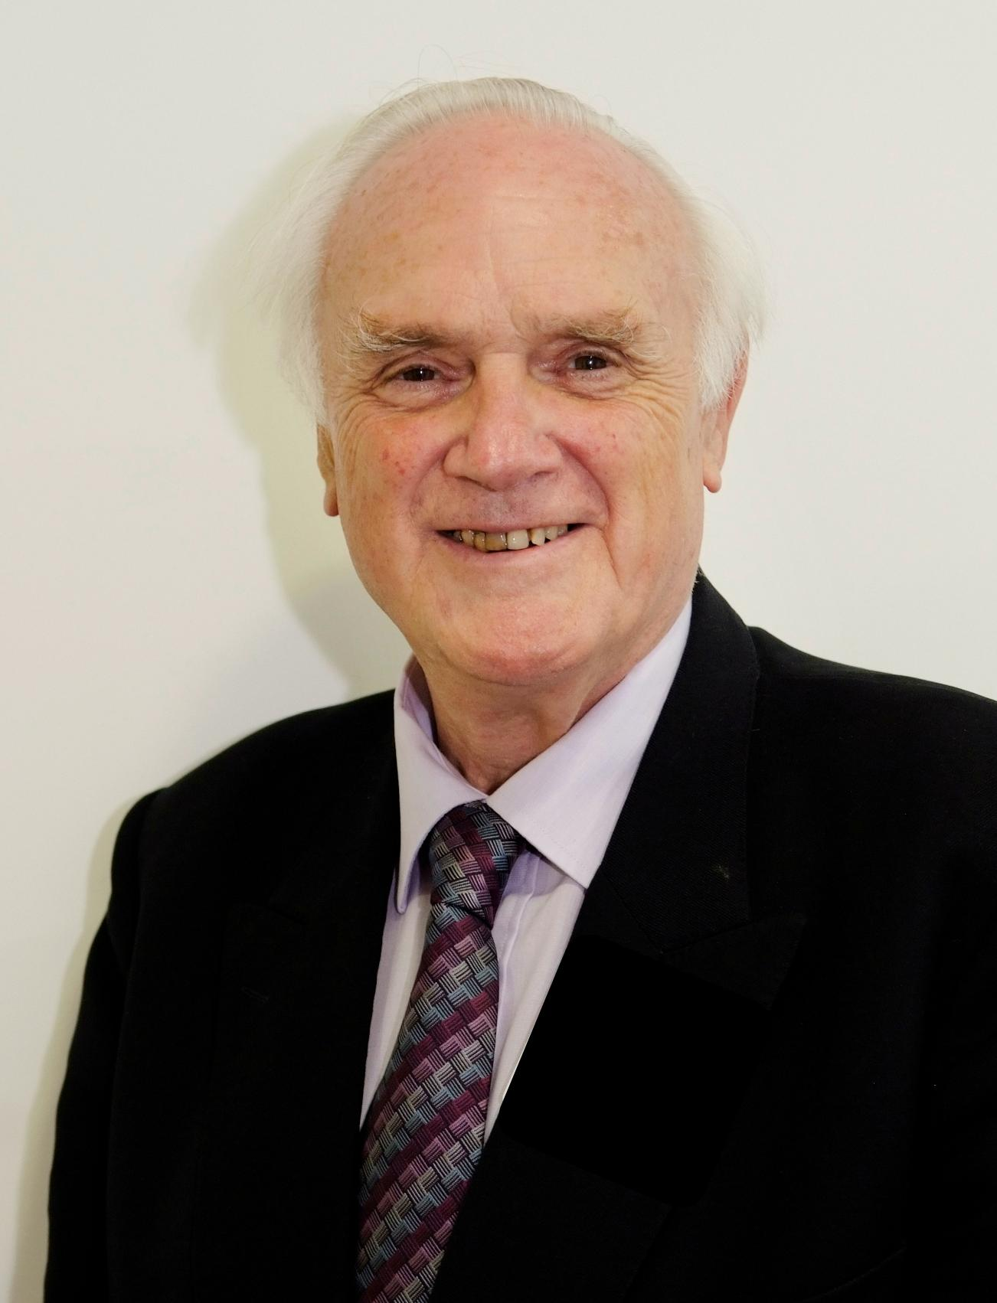A former fast jet pilot in the RAF, Kel - a Tenant Board Member - rose to the rank of Group Captain. He also spent a number of years with the Ministry of Defence in Whitehall before leaving to work in the defence industry.

Since retirement to Fernhill in Mountain Ash, he has become very active in community affairs, receiving the Queen's Award for Voluntary Service in 2004.

Kel is Trivallis' longest-serving tenant board member.

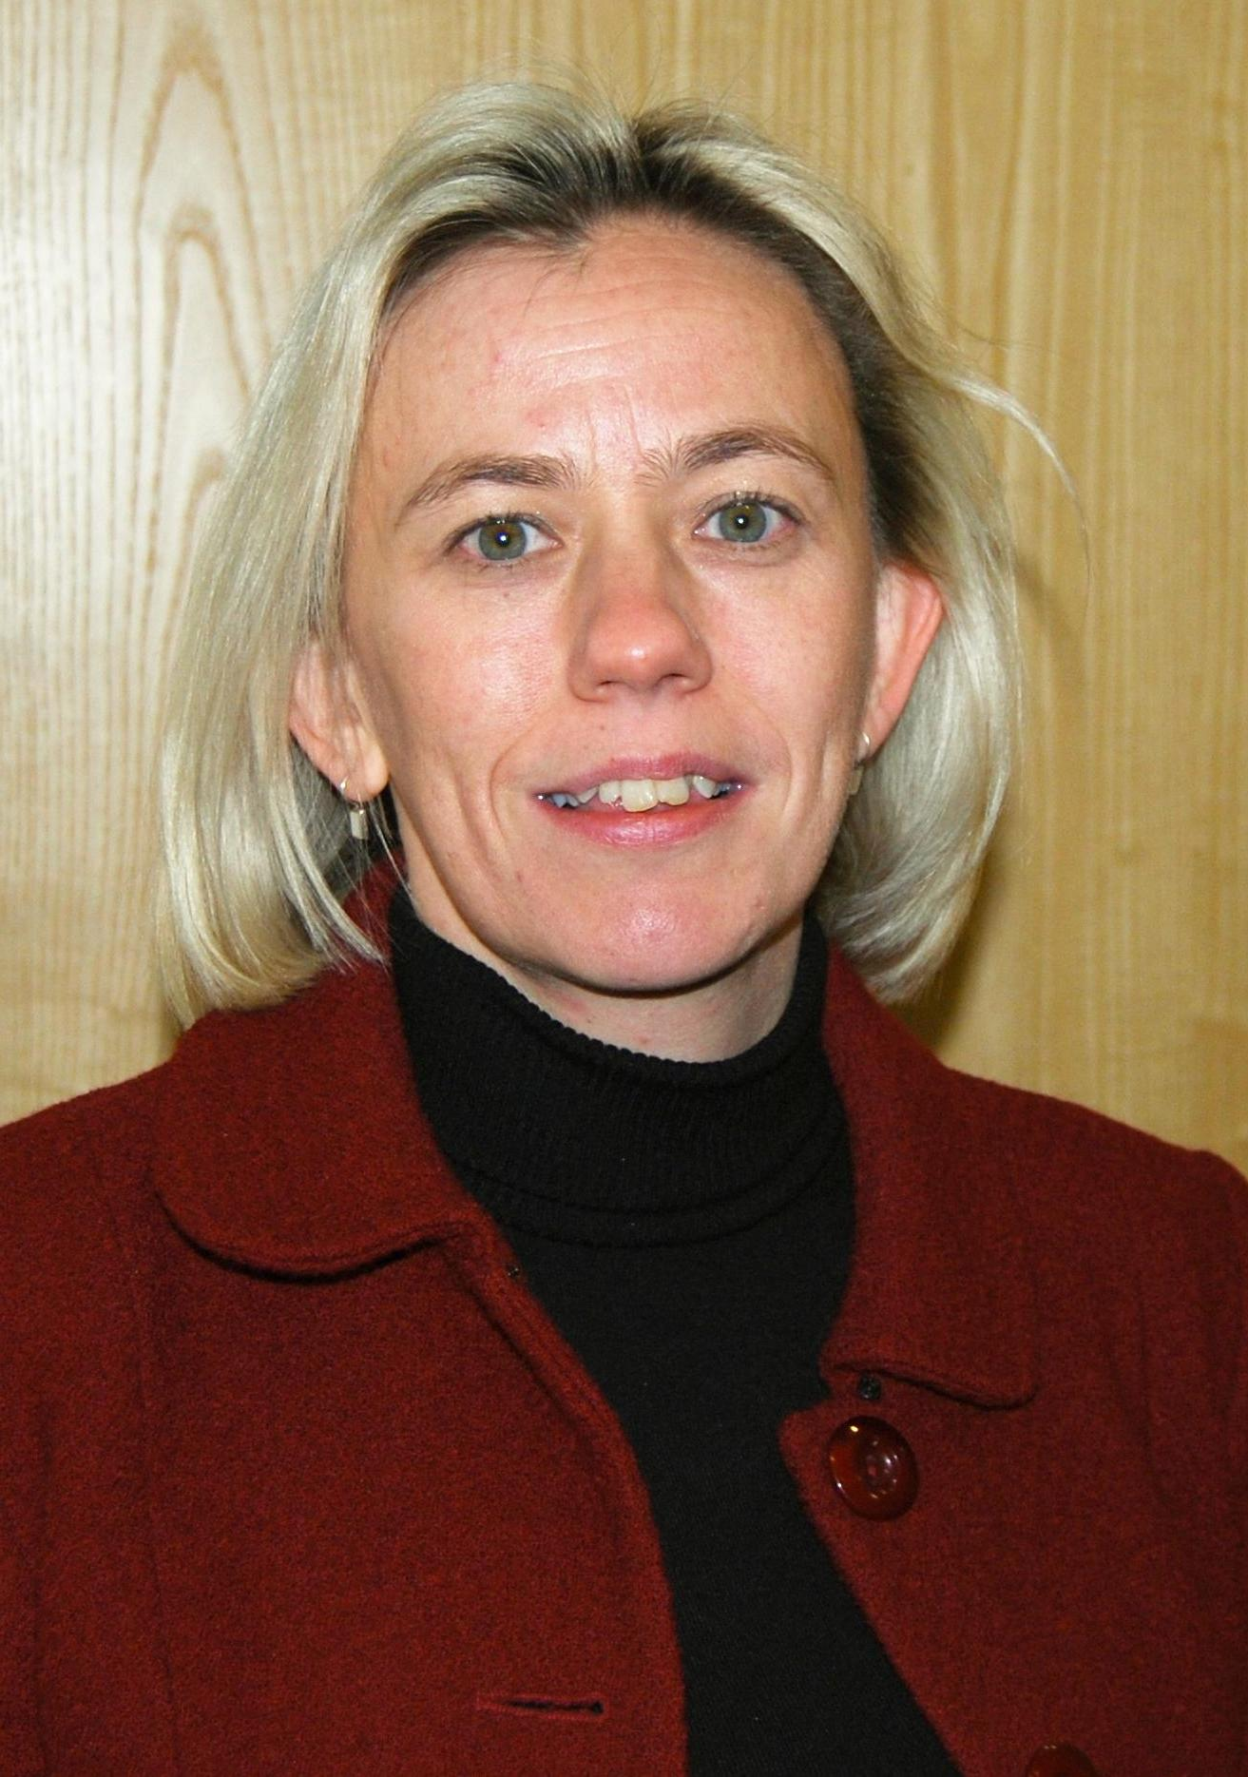

**Lynn Pamment**

Lynn is the partner responsible for leading accountants PricewaterhouseCoopers' Government and Public Sector practice in Wales and the West.

An Independent Board Member, she has more than twenty years' experience of working with housing associations and their audit processes.

**Leighton Knowles**

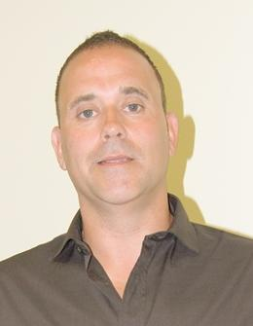Leighton is a Trivallis tenant and a Rhondda boy, born and bred.

Along with experience as Chair of Merthyr and Valleys Mind – the UK’s leading mental health charity - Leighton has also advised organisations on equality and diversity issues.

Passionate about these issues Leighton is familiar with complex topics of funding and budget-setting as well as working with regulators.

**Tom Pritchard**

Tom has a degree in Business Studies and 20 years’ experience in retail and commercial services, where he has maximised revenue and improved business performance for a number of organisations.

Most recently he has managed a number of projects at Director Level for Greensquare Group – a social housing group providing housing solutions to 10,000 customers.

**Don Snow**

Don is a partner in the Cardiff based Mandix consultancy. He has worked extensively in the field of sustainable regional and urban development following an early career with Cardiff City Council and the National Building Agency; for whom he set up office in Wales.

Don has advised businesses, government departments, the EC and OECD. He was a founding member of the Board of Constructing Excellence Wales, for whom he championed sustainable construction.

Recently he has helped Cardiff Metropolitan University develop and deliver the successful Construction Futures Wales programme on Management and Leadership.

**The Executive Team**

**Adrian Barber - Interim Chief Executive Officer**



Adrian has worked in housing for 29 years, starting his career as a Housing Officer in Tunbridge Wells, Kent.

In 2005, Adrian become a Housing Consultant and Interim Senior Manager and has since worked with a wide range of organisations including major housing association groups, ALMOs, LSVTs, Local Authorities and a representative body for all London Councils.

Adrian began his career at Trivallis in February 2014 as a Housing & Repairs Director, responsible for most of the customer facing landlord services. In September 2015 he moved into the role of Interim Chief Executive.

Adrian has a passion for implementing new and innovative service delivery models; using new technology, embracing fresh thinking and cutting out waste to improve the customer experience.

**Maxine Wiseman - Organisational Development Director**



Maxine has 11 years’ experience in the Welsh housing sector.

She has re-defined the role of the Organisational Development team, which comprises of Human Resources, Learning & Development, Communications & Media and Health & Safety and is responsible for connecting plans, people and processes to make sure the business is as successful as it can be.

A Fellow of the Chartered Institute of Personnel and Development (CIPD) and a Member of the Chartered Institute of Housing (CIH), Maxine has a successful track record of supporting organisational change. She was recently awarded with Wales' Institute of Directors HR Director of the Year.

At Trivallis, Maxine is responsible for ensuring that the organisation has the committed, ‘fit for the future’ workforce needed to deliver its strategic ambition. She plays a vital part in ensuring that the organisation’s culture, values and environment support and enhance its performance and adaptability.

**Julie Vellucci - Business Development Director**

A chartered accountant with over 30 years’ experience in the public and housing sectors, Julie has worked in various roles at Newport City Council from Audit Manager to Head of Regeneration and Regulatory Services.

Julie led on securing and the delivery of the largest Welsh Government grant award under the Vibrant and Viable Places regeneration programme.

She successfully set up the Council's property service joint venture company, as well as gaining adoption of its local development plan.

Julie joined Trivallis in May 2015 as Deputy Director of Commercial and progressed through Acting Commercial Director to Director of Business Development.

She has experience of regeneration led development, strategic asset management and continuous service improvement.

At Trivallis, Julie is responsible for the new build and regeneration programmes, asset management and service improvement.

**Lynda Clarke - Finance Director**

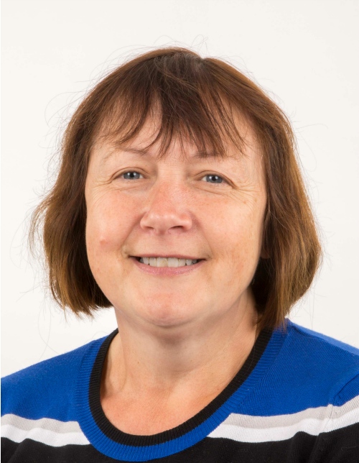Lynda has 24 years’ experience in the Welsh housing sector.

She previously worked for Newport City Homes, where she helped to manage the stock transfer and set up the organisation.

After leaving Newport City Homes in March 2016, she was an Interim Finance Manager with Powys Council, evaluating and reviewing the Finance Team to deliver improved services.

Lynda is a Fellow of the Chartered Institute of Certified Accountants (ACCA).

At Trivallis, Lynda is responsible for the Finance, Income Recovery, Governance and Informatics departments.

**Bob Granville - Homes and Neighbourhoods Director**

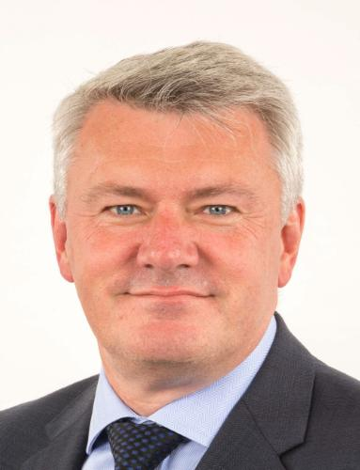With 30 years’ experience in social housing, Bob is overseeing the improvement of Trivallis’ repairs service and voids services, two of the key priorities for the organisation.

He has been a member of executive teams for the past 10 years including roles as Deputy Chief Executive and Director of Operations.

A key personal driver is to improve performance whilst engaging customers in setting the standards for those services.

At Trivallis, Bob is responsible for the frontline service of the business, specifically housing management, repairs and maintenance, grounds maintenance, customer involvement and care and support services.

**Role Profile**

**Title of role:**

* Chair of The Board

**Overall purpose of the role:**

* Lead, challenge, mentor and harness a talented Board
* Provide strategic direction and guidance
* Ensure sound and effective governance
* Ensure that as an organisation, we are doing what we said we will do
* Ensure the organisation stays close to its roots and heritage as having grown and served our communities in the South Wales valleys
* Set the overall ‘tone’ for the organisation, keeping us honest and true
* Act as an ambassador and ‘figurehead’ for the organisation
* Support and provide constructive challenge to the Chief Executive

**Key Priorities:**

Immediate priorities

* The Board
  + Will have had a substantial churn (natural retirement due to reaching limits of terms served) by the time that the new Board meets in the autumn, so will need to work to create a collegiate and collaborative ‘team’
* The Chief Executive and Executive team
  + First major task for the new Chair will be to appoint a new Chief Executive and build a effective and constructive working relationship over the coming months
  + The Chair will also need to build sound and respectful working relationships with what is generally regarded as being a strong and effective team of Executive Directors
  + Satisfy yourself that the Executive team is delivering appropriately on the day to day work of the organisation per the business plan, and that all targets and metrics are being met
* Other relationships
  + Focus on building trusting and respectful relationships with the Regulator
  + Do the same with other key external stakeholders, including tenants and our communities
  + Establish your profile and that of other board members within the organisation

Medium term priorities (12-24 months):

* + Look at opportunities arising from the new government following ONS re-classification
  + With the Board, the Chief Executive and the rest of the Executive Team, begin to look at the next stage of evolution for the organisation, and agreeing a new and updated vision and business plan

**Role reports to:**

* The Board

**Responsible for:**

* The role leads and chairs a Board of 12 (including the Chair) made up of:
  + 4 individuals nominated by the Council
  + 4 individuals elected by tenants
  + 4 independent board members

**Key relationships:**

* Internal
  + Chief Executive and Executive Board
* External
  + Regulator
  + Funders
  + Council
  + Community representatives
  + Other public bodies

**Performance in role will be judged by:**

* Objectively:
  + Annual appraisal by board members
* Subjectively
  + Feedback from Regulator, Funders and other stakeholders

**Person Profile**

**Part One:**

These are the requirements, against which we will assess your written application, so please be sure to address each of them when putting your application together, and ideally providing examples of how you meet them.

**Essential:**

A demonstrable, successful and proven track record of**:**

* Working and contributing at board level (in any sector)
* Being a high profile influencer
* Understanding fully the difference between being an exec and non-exec, and the behaviours and working pattern required of the latter
* Experience of a business/enterprise/organisation of at least similar size to Trivallis
* Deploying a strategic head/mind-set

**Desirable, but not strictly essential:**

A demonstrable, successful and proven track record of**:**

* Previous experience of chairing a board
* Senior level experience of a really large and complex organisation   
  (any sector)
* Experience of a series of Non-Executive Director roles, across various sectors/community wide, that has enabled you to build up a real feel for how different boards operate
* Having built constructive relationships with a chief executive
* A track record of supporting, mentoring and holding a chief executive to account

**Part Two:**

If invited to interview, the criteria outlined in Part One (above) will be tested further, along with the core skills and personal attributes listed as follows.

**Style, skills, attitudes, behaviours:**

To survive and thrive within, as well as deliver for the organisation…

Trivallis and its service users, tenants and communities

* You will have a strong affinity with the mission, vision and purpose of Trivallis and the challenges facing our communities

Working with fellow board members

* You encourage full participation and expression of considered opinions at Board meetings and in committees in a constructive, collegiate and respectful manner

As a professional

* You are strategically aware and possess a good sense of organisational complexity and the challenges of change
* You understand modern technology and the use of digital

As a person

* You are confident, with a strong intellect
* You are motivated to work collaboratively with other board members, and draw out/harness their skills and knowledge

**Part Three – Chemistry and “Fit”**

**We posed a series of questions on your behalf to existing Board members**

**‘What has the current Chair been like to work with, and what qualities would you like to see again?’**

* *We’d say that our retiring Chair has been:*
  + *Honest, truthful and respectful;*
  + *Led us through some tough times;*
  + *Fostered/encouraged/developed a board that has bonded together and is cohesive;*
  + *Has kept us together;*
  + *Utilises a quiet sense of authority;*
  + *Has a good sense of humour;*
  + *Is very approachable;*
  + *Encourages trust and confidence;*
  + *Is naturally sharing; and*
  + *Is a good mentor.*

*So, ideally, we’d like to see all these qualities again in our new Chair*

**‘And given how Trivallis has grown and developed over the last 10 years, any other qualities that would be especially useful, this time around/qualities that you would like to emphasise again?’**

* *A natural networker;*
* *Creative and innovative, and brings out those talents in others;*
* *Rock solid on governance;*
* *Keen on dashboards and metrics;*
* *A very sound and strategic business head;*
* *A strong character, but with an ego totally under control;*
* *A born ‘natural’ on constructive challenge; and*
* *Has absolute personal strength and integrity.*

**‘And what works less well with you and your other board colleagues?’**

* *Arrogance;*
* *‘Been there, seen it, done it’ attitude;*
* *Patronising;*
* *Doesn’t listen;*
* *Doesn’t draw in the contributions of colleagues;*
* *Lack of clarity; and*
* *Is insular and closed.*

**We then asked the retiring Chair ….**

**‘What was your motivation for joining the Board of Trivallis, why are you retiring, and what has kept you here these past 10 years?’**

* *I’m retiring because I have reached the limit of terms I am allowed to serve;*
* *For me, what got me onto the Board in the first place was the notion of giving something back to the community;*
* *I care deeply for the values, economy, health and well-being of the Valleys, and the communities who live and work here – and I feel that this will be the real draw in attracting a new Chair; and*
* *What we do is immensely important – and it has been a real privilege to be Chair.*

**‘And what is the likely time commitment?’**

*In honesty, that has gradually been increasing:*

* *In theory, it is meant to be at least two days a month*
* *Will inevitably be somewhat higher in the first year of office*
* *After that first year and with someone who manages their time efficiently, it should get back to around 2 days a month.*

**‘And the duration of Board appointments?’**

*The maximum term of appointment is currently 9 years (3 x terms of 3 years), but this is currently under review by the Governance Committee and might be reduced to 6 years (3 x terms of two years).*

**Date from when this appointment takes effect**

*Ideally, it is intended that this appointment will take effect as of 01 September 2017 (subject to a review after one year).*

**‘If potential candidates meet all the criteria above, then they will likely have many attractive alternative options re where to allocate their valuable time. So why ought they to consider investing personal time/persuade their employer to allow them time to join the Board of Trivallis?’**

*Any one or a combination of the following:*

* ***The sector that we operate within***
  + *If you feel that it’s important to try to transform life outcomes for vulnerable people, then you can have a huge impact by volunteering as a non-executive in the social housing sector; that means you must be optimistic about the future and have a belief in people’s potential and want to invest in that*
  + *You will have a chance to influence, guide and be at the forefront of developments in social housing and related services*
* ***Our region***
  + *Trivallis is and has the potential to be a major/even greater player in the Cardiff City Region*
* ***Our place***
  + *This is Wales; this is the Welsh Valleys; there is a magic about this place that energises and inspires; and if you already live here, then you know that for yourself*
* ***Our communities***
  + *The chance be the figurehead for and influence an organisation that makes a real difference to people’s lives out there in the community*
* ***Trivallis***
  + *We are most effective at targeting and helping those in need; so if you are keen to be a key part of and influence an organisation that is making a real difference, then this is your chance*
  + *We have a strong reputation, we have a strong exec team and we have a capable and highly motivated/energised staff with high morale*
  + *We are ambitious*
  + *We are financially stable and have the resources to invest*
  + *This is a great opportunity to support those who are delivering something meaningful ‘on the ground’*
* ***Personal experience and growth***
  + *This is a chance for you to contribute your knowledge, expertise and enthusiasm and to harness for the benefit of others the advantages and opportunities you have had - that they may not yet have enjoyed*
  + *It is an opportunity to support and further encourage the development of the Executive Team setting a tone and culture of adding real value to our staff and to our communities*
  + *An ambitious and supportive Chair with an open heart and mind will really flourish here*

**‘And what might they be doing now/where might they be?’**

*Any one or a combination of the following:*

* *Currently working fulltime/approaching retirement/recently retired from a senior position, from which you have been/are required to influence and constructively challenge by asking the right questions in the right manner at the right times*
* *On one or more boards, within any sector/s*
* *An existing Chair of one or more boards within any sector/s*

**Terms of Appointment**

**Contract**

9 years maximum (3 terms of 3 years)

**Remuneration**

Voluntary Role, reimbursement of reasonable expenses and provision of iPad

**Location**

Board meetings take place in Ty Pennant, Mill Street Pontypridd

**How to Apply – for this role**

This guidance contains important information to help with your application.

**General Conditions**

We recognise and welcome our responsibility to remove any barriers in our Recruitment and Selection process for disabled people. We have tried to do this, but if you have a disability and identify any barriers in the job description please tell us of these in your application. We are committed to making reasonable adjustments to the role wherever possible and it would help us to know your needs in order to do this.

**To apply for this role, we would like you to provide the following:**

* A motivation statement (ideally no more than 2 sides of A4), which explains why you are applying for this role and the contribution, style, skills and experience you will bring to it.
* A supporting statement, providing evidence/examples of how you match the essential and desirable attributes, as outlined in Part One of the ‘Person Profile’.
* A comprehensive, up to date and current CV.
* Contact details of two referees so that we are able to take up your references if you are shortlisted for final panel interview (referees will not be contacted without your permission).
* A completed Equal Opportunities monitoring form (see below). We are keen to ensure that our roles are accessible to all members of the community and use this data to monitor our progress in doing this.

The equal opportunities and monitoring form can be found at the end of this pack. This is a word document that you need to complete and return to us by email.

Please ensure you return the above documents to:

[**TR1054@davidsonpartners.com**](mailto:TR1054@davidsonpartners.com)(Chair)

On the following pages, there is an indicative timetable for this appointment.

Please ensure that you let us know in your covering letter if there are any specific dates that present you with a problem.

**Indicative Timetable for the Chair appointment**

**Shortlisting:** 01 November

**Informal Meetings with Interim Chair:** To be arranged

**Final Panel Interview:**  06 or 07 November

**Confidential Discussion**

If you would like to have an informal/confidential discussion about this role, please contact our advisors: Hamish Davidson on 07932 698807, Leon Ward on 07871 044649, Jack Williams on 07885 670504, or, or email them at:

[leon.ward@davidsonpartners.com](mailto:leon.ward@davidsonpartners.com)

[jack.williams@davidsonpartners.com](mailto:jack.williams@davidsonpartners.com)

[hamish.davidson@davidsonpartners.com](mailto:hamish.davidson@davidsonpartners.com)

**Further Information**

To assist you further in developing your understanding of Trivallis we have provide some useful links to aid your research into the organisation and the role:

[Annual Review and Financial Reports – 2017](https://www.trivallis.co.uk/our-reports)

[Welsh Government Regulatory Judgement June 2017](https://www.trivallis.co.uk/download.cfm?doc=docm93jijm4n874.pdf&ver=1340)

[Trivallis Core Values](http://careers.trivallis.media/values-set.html)